**Lab Assignment -2 (DDL and DML)**

Name- KESHAV GARG

Id- 2018UCP1674

**Ans-1.** CREATE TABLE Employee ( Emp_id int, First_name varchar(20), Last_name varchar(20), Email varchar(20), Address varchar(50), City varchar(15));

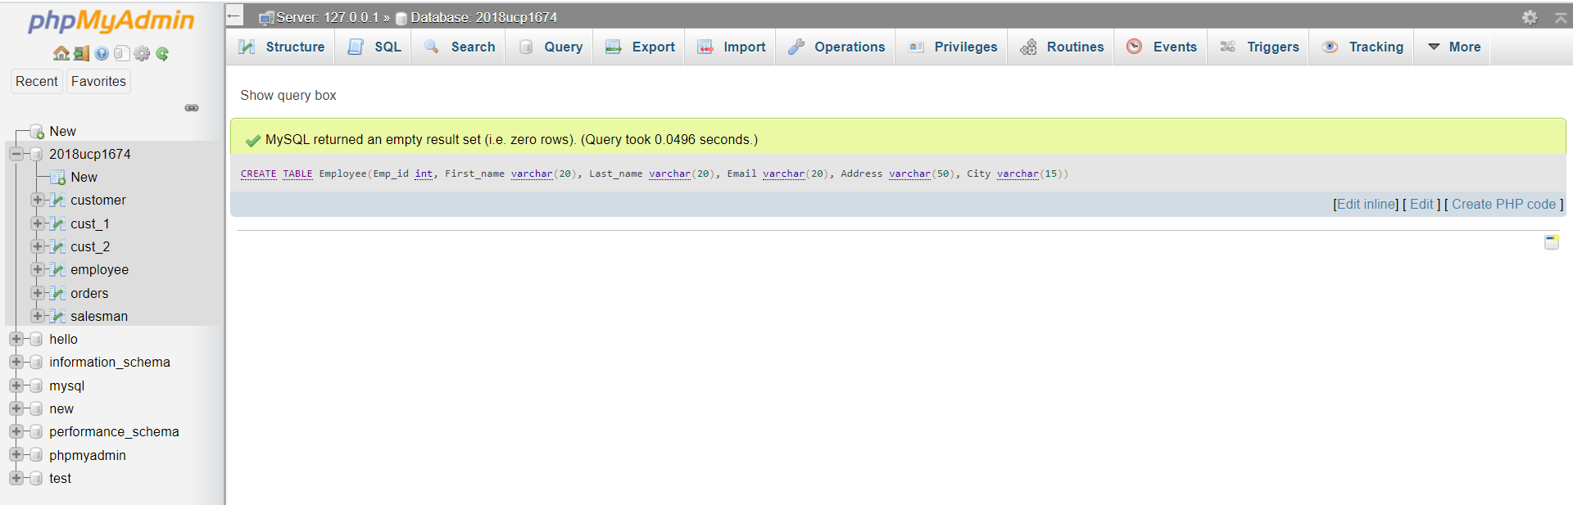

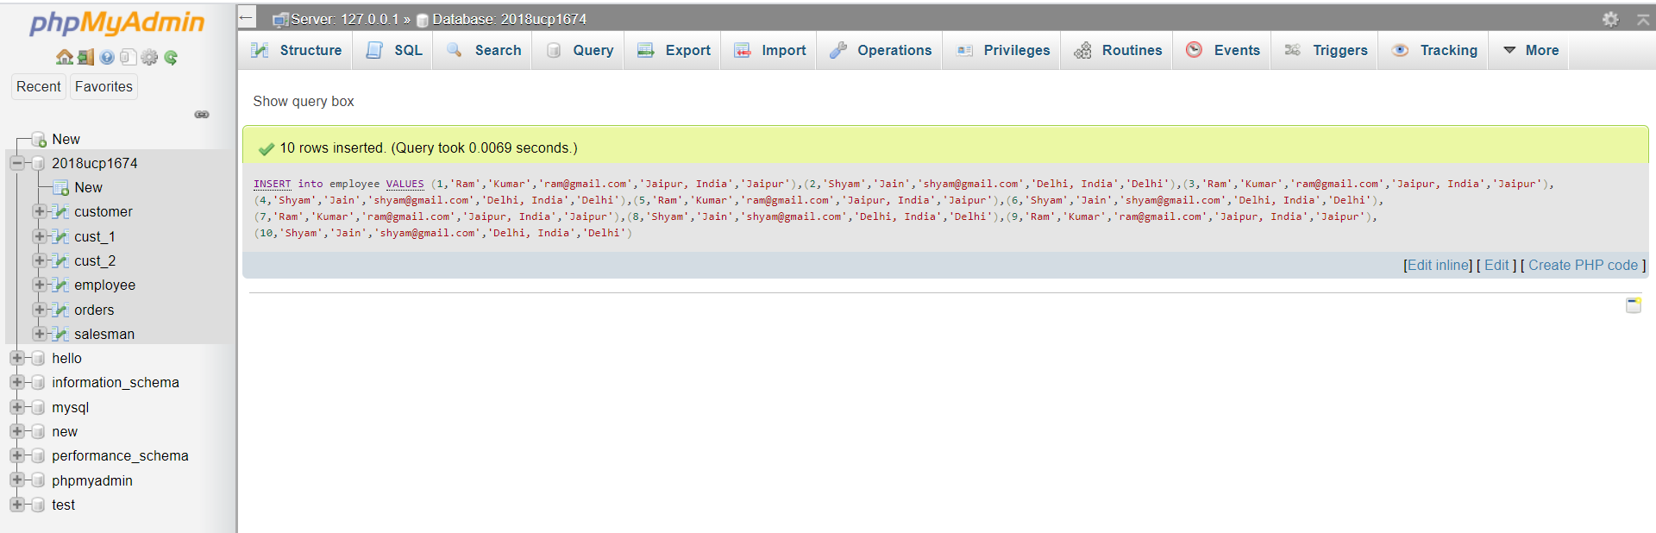INSERT into employee VALUES (1,'Ram','Kumar','ram@gmail.com','Jaipur, India', 'Jaipur') ,(2,'Shyam','Jain','shyam@gmail.com','Delhi, India', 'Delhi'), (3,'Ram','Kumar','ram@gmail.com','Jaipur, India', 'Jaipur') ,(4,'Shyam','Jain','shyam@gmail.com','Delhi, India', 'Delhi') ,(5,'Ram','Kumar','ram@gmail.com','Jaipur, India', 'Jaipur') ,(6,'Shyam','Jain','shyam@gmail.com','Delhi, India', 'Delhi') ,(7,'Ram','Kumar','ram@gmail.com','Jaipur, India',' Jaipur') ,(8,'Shyam','Jain','shyam@gmail.com','Delhi, India', 'Delhi') ,(9,'Ram','Kumar','ram@gmail.com','Jaipur, India', 'Jaipur') ,(10,'Shyam','Jain','shyam@gmail.com','Delhi, India', 'Delhi');

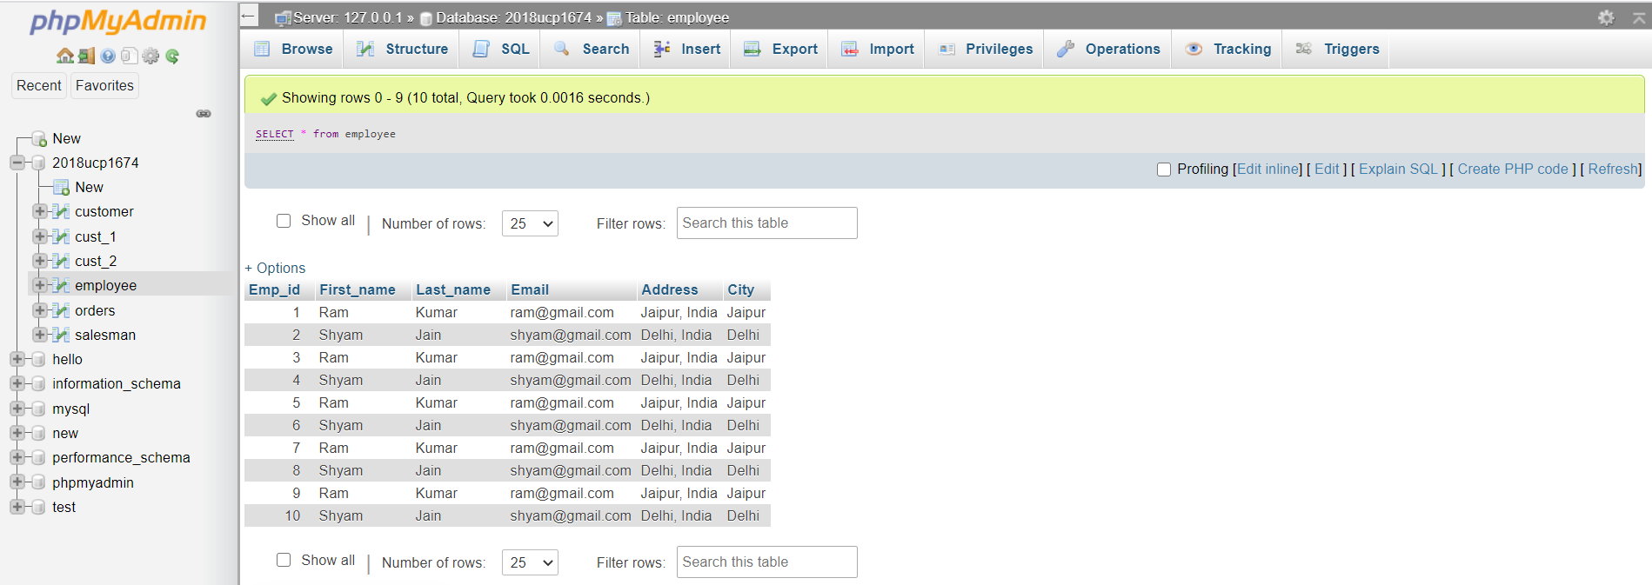

**Ans-2.** ALTER TABLE employee MODIFY Email varchar(30); 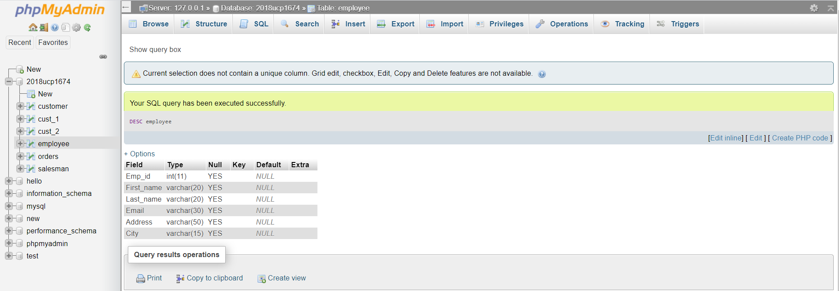

**Ans-3.** ALTER TABLE employee ADD COLUMN DOJ date; 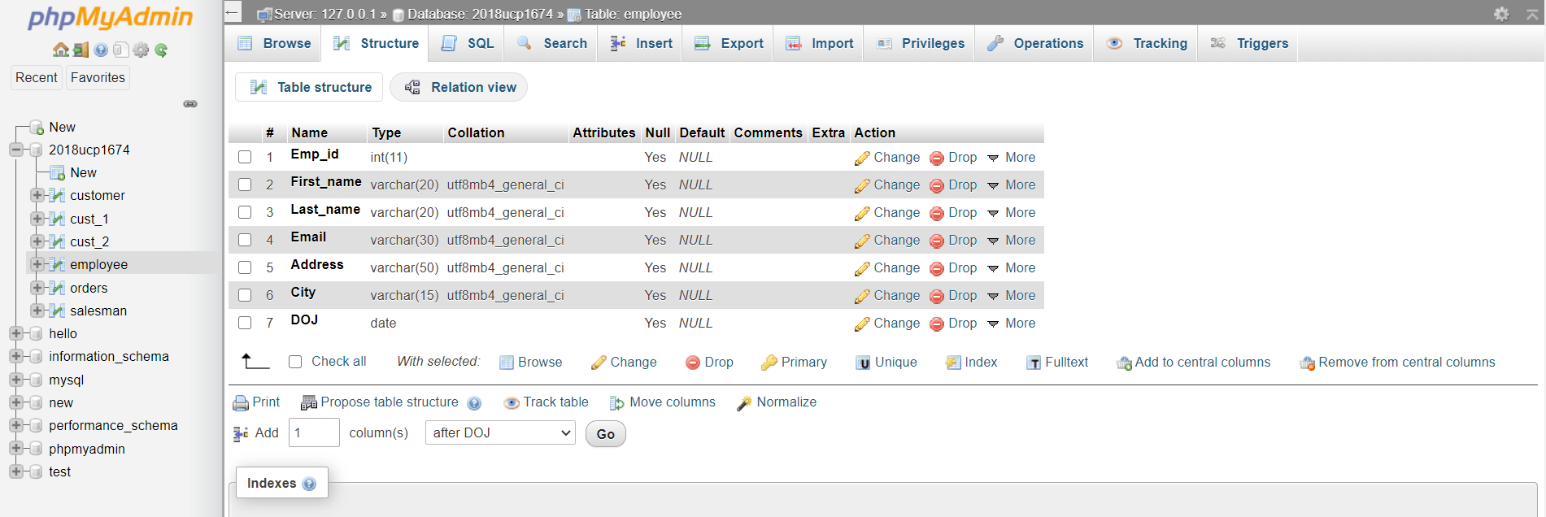

**Ans-4.** ALTER TABLE employee ADD COLUMN DOB date NOT null DEFAULT '2020-01-01'; 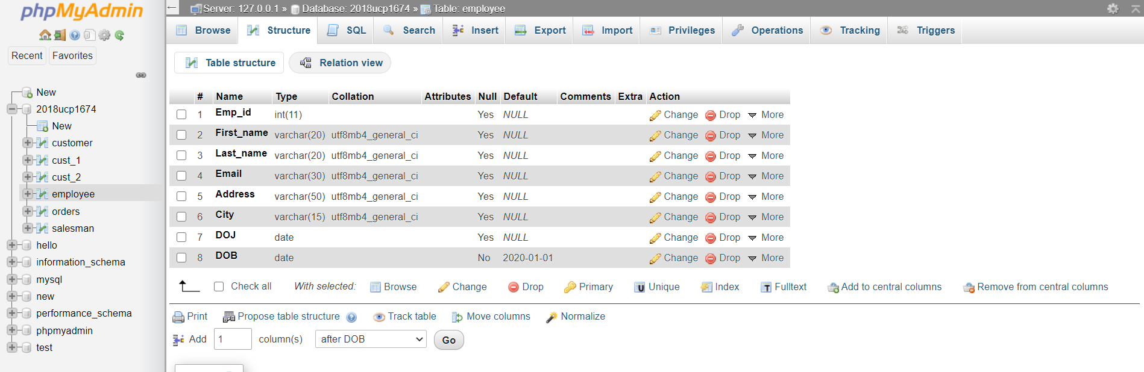

**Ans-5.** ALTER TABLE ADD PRIMARY KEY (Emp_id); 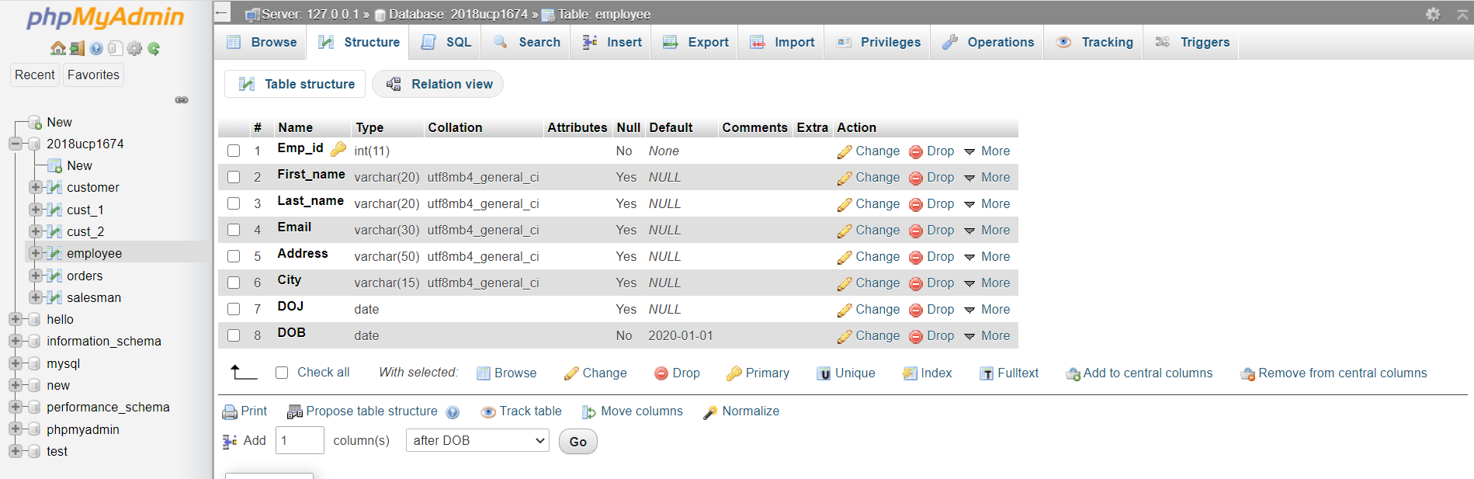

**Ans-6.** 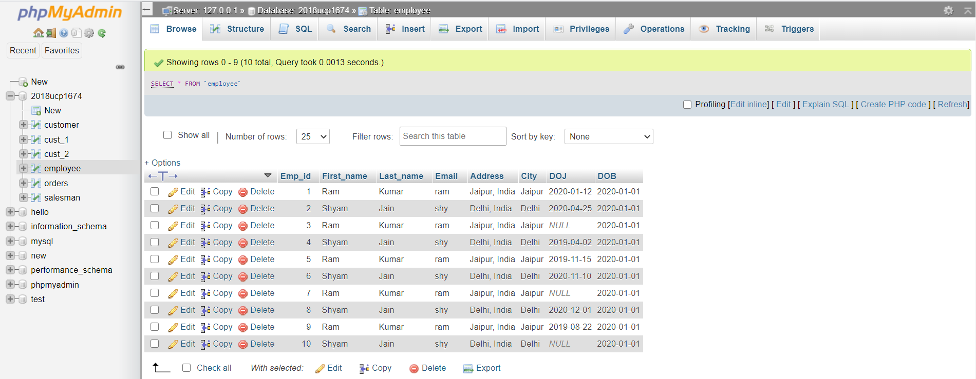

DELETE FROM employee WHERE DOJ is null; 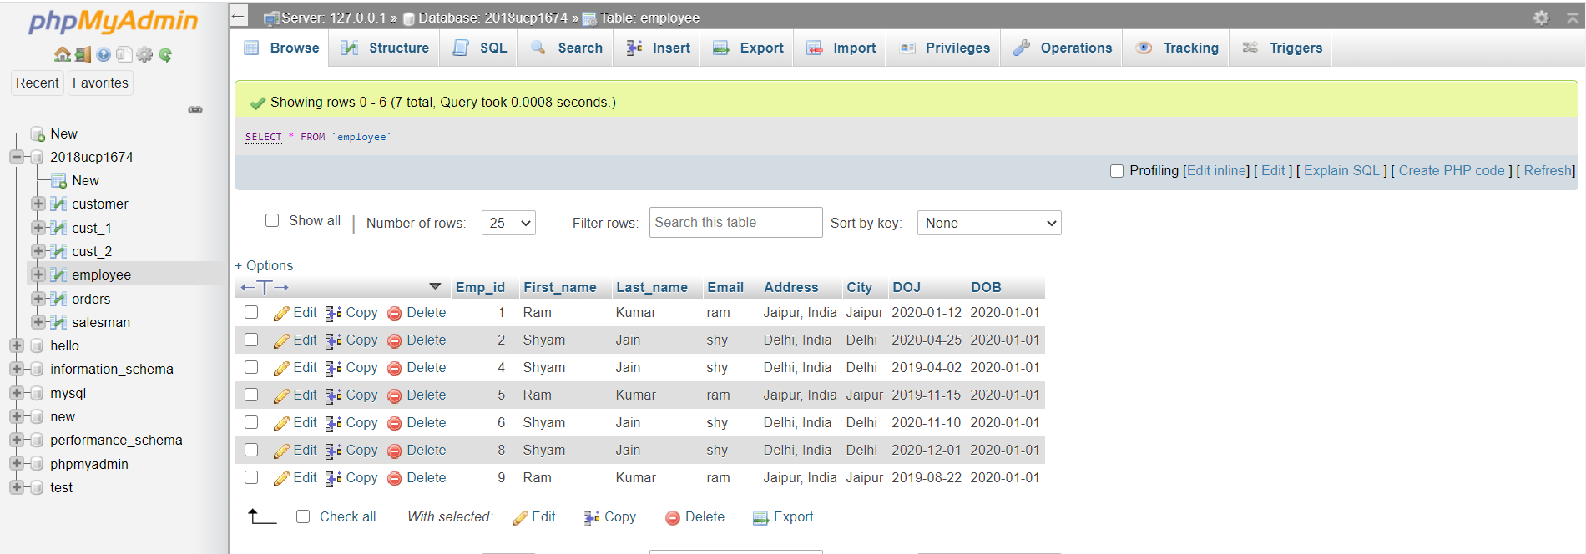

**Ans-7.** UPDATE employee e SET e.City='Gurgaon' where e.City='Delhi'; 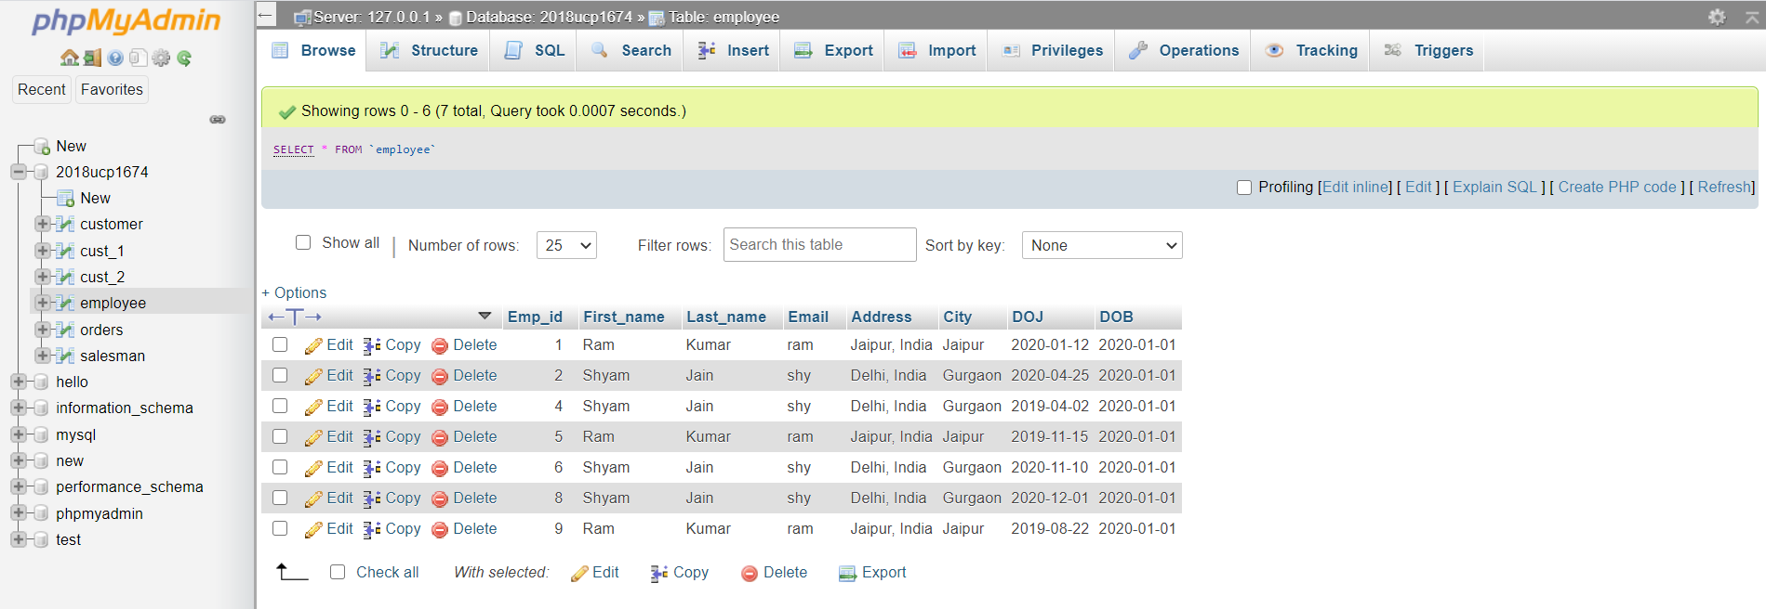

**Ans-8.** DELETE FROM employee; 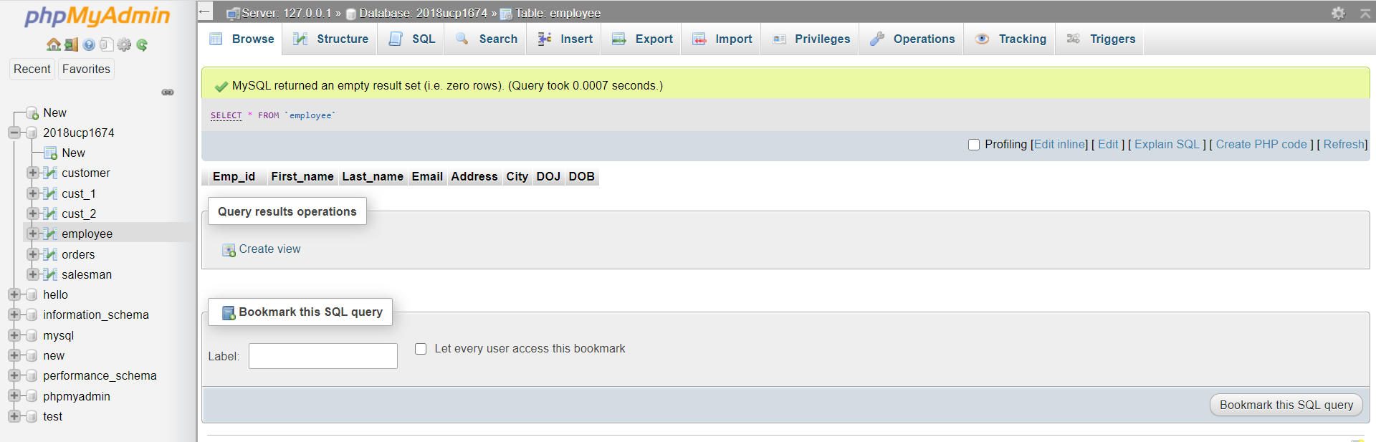

**Ans-9.** RENAME TABLE employee TO Emp_id; 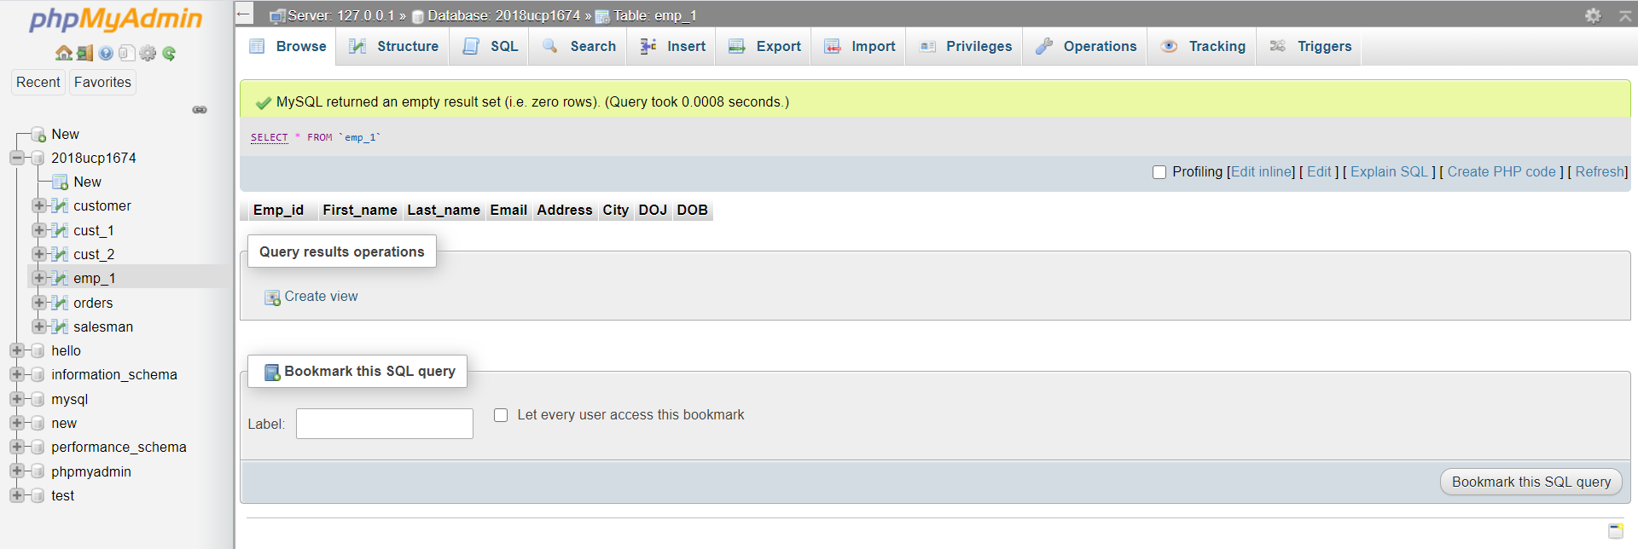

**Ans-10.** INSERT INTO emp_1 VALUES (3,'Ram','Kumar','ram@gmail.com','Jaipur, India', 'Jaipur','2020-01-05','2020-01-05') ,(4,'Shyam','Jain','shyam@gmail.com','Delhi, India', 'Delhi','2019-05-25','2020-01-05') , (5,'Ram','Kumar','ram@gmail.com','Jaipur, India', 'Jaipur','2020-04-15','2020-01-05') , (6,'Shyam','Jain','shyam@gmail.com','Delhi, India', 'Delhi','2020-09-25','2020-01-05') , (7,'Ram','Kumar','ram@gmail.com','Jaipur, India',' Jaipur','2019-12-25','2020-01-05'); 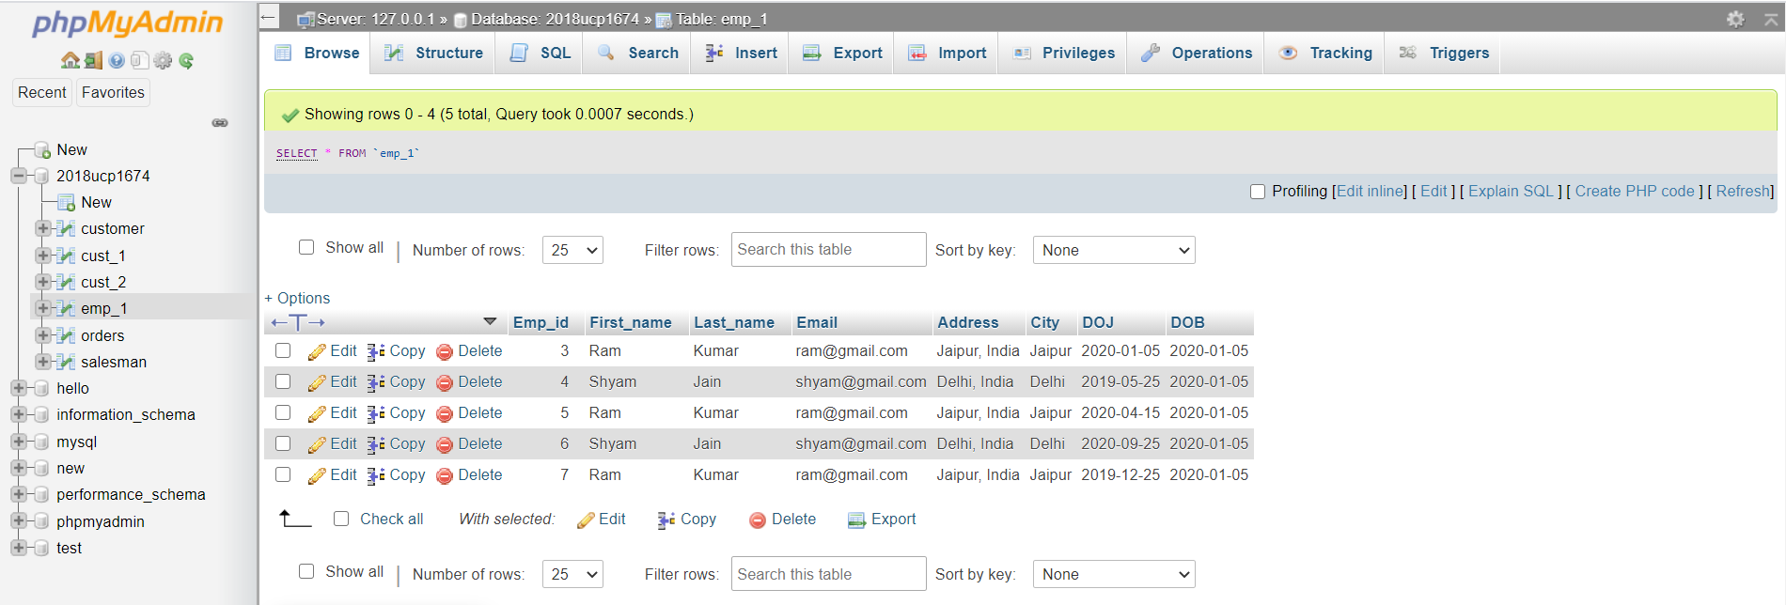

DROP TABLE emp_1; 